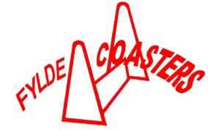
Fylde Coasters Flyball Team 2017

Spring/Summer Indoor Training Evenings

Our Spring/Summer training nights will continue at Midgeland Riding School, 460 Midgeland Road, Blackpool, FY4 5EE.

Below are the Indoor training dates every other week on a Wednesday evening from 7.30pm

Wednesday April – 5th, 19th

Wednesday May – 3rd, 17th, 31st

Wednesday June - 14th, 28th

Wednesday July – 12th, 26th

Wednesday Aug- 9th, 23rd

Wednesday Sept – 6th , 20th

Wednesday Oct – 4th, 18th

Wednesday Nov – 1st, 15th, 29th
Training is aimed at giving the handler/dog a basic insight into what flyball is all about; you will work with your dog under the instruction of our trainers.

£25 for a 6 week course:- Block 1 April 5th, 19th, May 3rd, 17th, 31st, June 14th
Block 2 June 28th, July 12th, 26th, Aug 9th, 23rd, Sept 6th
Block 3 Sept 20th, Oct 4th, 18th, Nov 1st, 15th, 29th
- We welcome any breed of dog, however your dog needs to be sociable and a good recall is essential to play Flyball.
- Please remember not to feed your dog for at least 3 hours before coming to training.
- Good footwear is essential as well as sensible clothing. This is an all weather sport so come prepared.
- Your dog may need some tasty food such as hot dog sausage, chicken or cheese to encourage it during the class and to recall your dog back to you, or a ball on a rope.
- Your dog needs to wear a flat collar or a harness not a check chain.
- A proper lead is essential, not a flexi lead
- Always bring a poop scoop and clean up after your dog as the grounds are used by a variety of other clubs.
- Please take your dog poop home with you
- This is a riding school so please always keep your dog on a lead, and respect the rules around the horses.
- Please do not stroke or feed the horse as this is their bedtime.

If for any reason there is no training I will email or text you, to let you know
Arrive/Set up :- 7.25pm – 7.30pm
Beginners/Starters :- 7.30pm – 8.15pm (Starters netted lane - 45 min class)
Intermediates/Team 7, 11 and 14inch jump heights :- 7.30pm – 8.30pm (no netting/wings)
For more information Please contact: -

Daniella Mann (Team Captain) 07759263563 or dnm@waitrose.com

Lynne Wagstaff 07793866698 or lynnewaggy@outlook.com

Les Chapman 07722206369 or bryn2832@gmail.com
Or you can visit our team website and leave us a message on http://fyldecoasters.weebly.com/
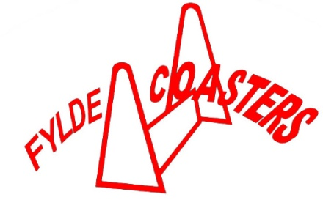
Fylde Coasters Application Form

Name :-_____________________________________________________

Address:- ___________________________________________________
____________________________________________________________

Post Code: -_______________________________________

Tel No: -_____________________________________________________

Mobile No: -__________________________________________________
Email:-______________________________________________________

Dogs Information

Dogs Name: -__________________________________________________

Dogs Breed: - __________________________________________________
Age: - D of B:_________________________
Health Issues we need to be made aware of:-_______________________________________
____________________________________________________________________________
(Dogs must be 12 months of age to start flyball training and be appropriately vaccinated)
Do you agree for you and your dog’s picture to be on our website?
Yes _________No________

Course Fees: - £25 for a 6 week course – (approx 45 min) Block ____________
*All dogs are entered on this course at their owner’s risk, whilst every care will be taken, the course organisers cannot accept responsibility for damage, injury or loss however caused to dogs, person or property whilst attending this course.
*Dogs must be fully vaccinated or similar precaution.
Please bring this application form, payment and current vaccination certificate with you to your first session.
Cheques made payable to:- Fylde Coasters Flyball Team

Owners Signature: -____________________________________________Date: -__________

Vaccination seen by: - __________________________________________Date:-__________

